- Lets remove this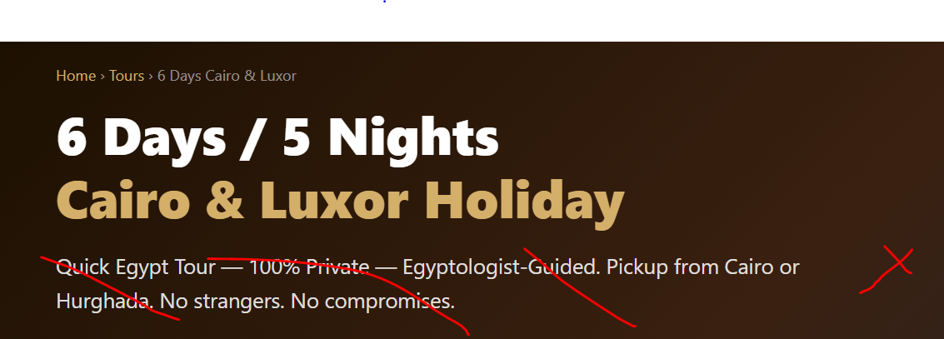
- This looks great

- Can we add a row to navigate the website as high end did right under the line above ( days/ nights): https://www.highendjourneys.com/tours/7-days-egypt-tour-package
- Overview: Dreaming of visiting Egypt but can’t spare much time? Then this one-week trip is perfect for you. You will see the highlights of Cairo plus the ancient city of Thebes (Luxor). Enjoy standing in front of the Pyramids and the Great Sphinx then visit the Egyptian museum with its incredible collection of antiquities. Take the night train to Luxor and explore that splendid historical city that has a lot to offer; such as The Valley of The Kings and The Queens, Karnak, and Luxor temples.
- Sites included (instead of highlights):
  - 🏛️ Giza Pyramids & Sphinx (Lets color them blue with hyperlink with a brief description and photos).
  - I think Memphis tours did that best where you click on the word and it takes you to another page. We don’t have to add a lot of words in the sub page as they did but we can add pictures.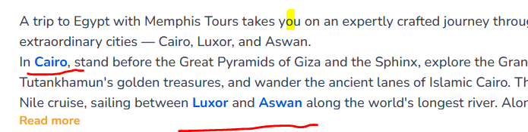
- Itinerary: (Looks good)
- Inclusions: What's Included looks good. Lets move Not Included
Next to What's Included just like what high end did 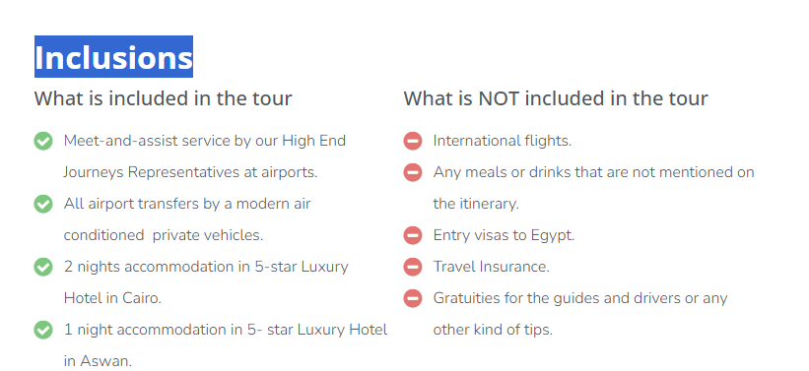
Other notes:
**Map: can we make the map a floating map to move up and down as you navigate the website. Lets use John’s Map
**Trip advisor: can we make it float to.
Optional Add-Ons Pricing, Children's Policy, Payment & Cancellation Policy
: Looks good

